THE SIX PHASES OF PECS®
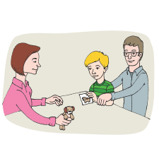

PHASE I
How to Communicate
Individuals learn to exchange single pictures for items or activities they really want.
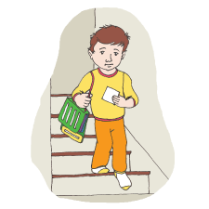

PHASE II
Distance and Persistence
Still using single pictures, individuals learn to generalize this new skill by using it in different places, with different people and across distances. They are also taught to be more persistent communicators.
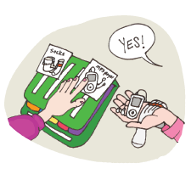

PHASE III
Picture Discrimination
Individuals learn to select from two or more pictures to ask for their favorite things. These are placed in a PECS Communication Book—a ringed binder with self-adhesive hook fastener strips where pictures are stored and easily removed for communication.
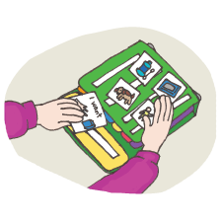

PHASE IV
Sentence Structure
Individuals learn to construct simple sentences on a detachable Sentence Strip using an “I want” picture followed by a picture of the item being requested.
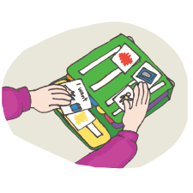

ATTRIBUTES & LANGUAGE EXPANSION
Individuals learn to expand their sentences by adding adjectives, verbs and prepositions.
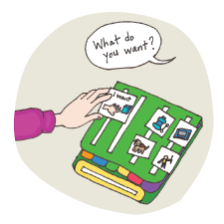

PHASE V
Responsive Requesting
Individuals learn to use PECS to answer questions such as “What do you want?”
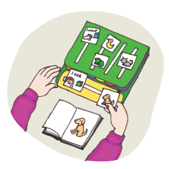

PHASE VI
Commenting
Individuals are taught to comment in response to questions such as, “What do you see?”, “What do you hear?” and “What is it?” They learn to make up sentences starting with “I see”, “I hear”, “I feel”, “It is a”, etc.

