IMMIATATION

What Is Imitation?
Imitation involves a child’s ability to copy others’...
- actions with objects (such as banging on a drum or pushing a car)
- gestures and body movements (such as clapping hands or waving)
- sounds or words
Typically-developing children learn to imitate in infancy. If you watch a baby and his mother interacting, you will likely see both baby and mother imitating each other’s sounds, actions, and facial expressions. This back-and-forth imitation is really an early conversation without words, and it helps infants learn to:
- express interest in their caregiver for social reasons (as opposed to expressing basic needs like food or sleep)
- share an emotion with their caregiver
- take turns
- pay attention to their caregiver

Imitation in Children with Autism
Children with autism often have great difficulty with imitation. Researchers have studied the imitation abilities of children with autism, and the effect this has on other areas of development. They have found that :
- their ability to imitate gestures and body movements predicts their language outcomes
- their ability to imitate actions with objects is related to the development of their play skills
- their difficulty with imitating other children’s actions affects their peer play
- they need to develop some imitation skills before they are able to acquire JOINT ATTENTION (the ability to share a focus with another person on an object)
Due to its connection to other areas of development, many researchers have suggested that imitation is an important focus of intervention for children with autism, and that teaching imitation should result in improvements in children’s overall social abilities.

Teaching Imitation
Many researchers have suggested that imitation is an important focus of intervention for children with autism.
A common way to teach children with autism to imitate involves having the child respond to the adult’s prompt to “Do this”, helping the child imitate the adult’s actions, and then rewarding the child’s correct attempt with a “reinforcer”, which could be a food or access to a favourite toy. This is the approach used in structured, behavioural therapy (often called “Applied Behavioural Analysis” or “Discrete Trial Training”). Imitation is drilled repetitively in this way, with the therapist selecting the toys or objects as well as the reinforcers.

Teaching Imitation During Natural, Social Interactions
Another way to teach imitation involves using a more natural approach. This approach is based on:
- including the child’s interests
- motivating the child to imitate; and
- promoting the social role of imitation.

Promoting Children’s Imitation Skills at Home
In response to the research on the social role of imitation in autism, The Hanen Centre has developed a new resource for parents: Take Out the Toys: Building Early Toy Play for Children with Autism Spectrum Disorder and Other Social Communication Difficulties. This is the second booklet in the Make Play ROCK™ booklet series, which gives parents strategies for building their child’s play skills, while also promoting important social interaction and communication skills.
https://www.amazon.com/s?k=MAKE+PLAY+ROCK&ref=nb_sb_noss_2 (AMAZON.COM)
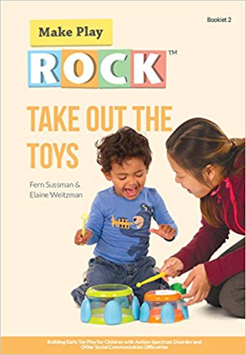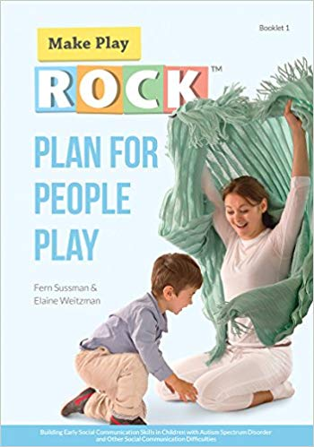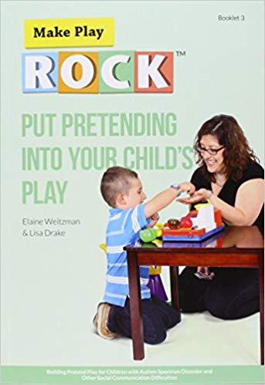

Take Out the Toys shows parents how they can encourage their child to imitate functional play with toys. Functional play involves playing with toys in expected or conventional ways, such as pushing a toy car, stacking rings or blocks, or putting shapes in a shape sorter.
Take Out the Toys describes how caregivers can help their child imitate some simple, functional actions with toys by:
- observing their child’s functional play with toys and objects
- imitating their child’s actions. This gets an interaction going, motivates the child, and helps him pay attention to his parents because they are imitating what he is doing with a toy of his choice. Imitation of a child’s actions often leads to the child imitating the parent’s action, which gets a back-and-forth interaction going.
- helping their child imitate an action with the child’s toy that is related to the play the child has already started. For example, if the child has been banging on a drum with his hand, the parent may grab a drum stick and bang on the drum, then hand the stick to the child.
- using cues to help their child imitate, such as waiting 10 seconds to see if he can do it on his own, or using hand-over-hand assistance if necessary.
- encouraging their child to keep interacting and have fun by showing enthusiasm, commenting about what the child has done, and imitating the child again.
Learning to imitate actions with toys and objects is the first step in learning to imitate, because object imitation is easier for children with autism than other forms of imitation (such as imitating gestures, facial expression, or sounds). By following their child’s lead and building on toys and actions in which their child shows an interest, parents can help their child learn to imitate a variety of functional actions with toys. This will expand the child’s play skills and set the stage for the development of other social communication skills. What’s more, because parents are encouraging imitation during natural social interactions that happen at home, the child will have more opportunities to practice, and he’ll be more likely to start using this skill in everyday life.
Imitation is more than just a simple game of copycat. For children with autism, it’s a key skill that they need to develop in order to progress in their social, play, and language development. By learning to imitate, children also discover fun new ways to interact with other people, and it’s during these social interactions that they learn the most.
(THE HANNAN CENTRE)

EXAMPLES OF IMMITATION ACTIVITIES

WITH OBJECTS
PUT SOMETHING IN A CUP
FEED THE BABY
STIR IN A CUP
TAKE SOMETHING OFFERED
PICK UP SOMETHING OFFERED
TURN ON A MUSIC/GAME DEVICE
PUSH IN THE JACK IN THE BOX
SCRIBBLE ON THE PAPER
SAY ‘AHH’
SAY “B’

WITH TOYS THEY PLAY WITH
PUT IN THE SHAPE
STACK THE BLOCK
FEED THE BABY
LICK ICECREAM
PUT ON STETHOSCOPE

WITHOUT OBJECTS BUT MAKE SURE THEY CAN SEE BODY PARTS
WIGGLE FINGERS
CLAP HANDS
ARMS UP AND DOWN
BANG ON TABLE
FLY LIKE A PLANE
PINCH FINGER TOGETHER
MAKE FISTS
SWING LEGS

SPEECH IMITATION
‘AHH’
‘B’
‘MMMM’
‘LALALALAL’

‘MAMAMAM’
KNEES UP
STOMP FEET

